Given the root of a binary tree, the depth of each node is **the shortest distance to the root**.

Return *the smallest subtree* such that it contains **all the deepest nodes** in the original tree.

A node is called **the deepest** if it has the largest depth possible among any node in the entire tree.

The **subtree** of a node is a tree consisting of that node, plus the set of all descendants of that node.

**Example 1:**

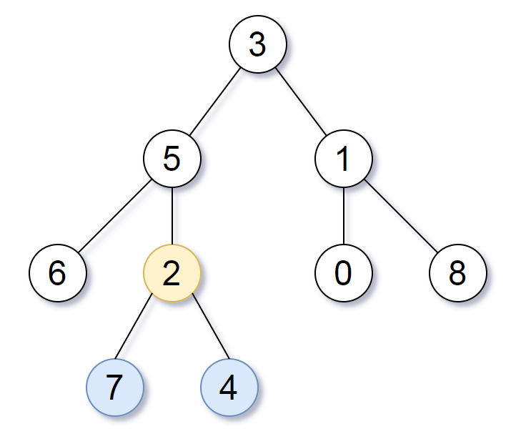

Input: root = [3,5,1,6,2,0,8,null,null,7,4]  
Output: [2,7,4]  
Explanation: We return the node with value 2, colored in yellow in the diagram.  
The nodes coloured in blue are the deepest nodes of the tree.  
Notice that nodes 5, 3 and 2 contain the deepest nodes in the tree but node 2 is the smallest subtree among them, so we return it.

**Example 2:**

Input: root = [1]  
Output: [1]  
Explanation: The root is the deepest node in the tree.

**Example 3:**

Input: root = [0,1,3,null,2]  
Output: [2]  
Explanation: The deepest node in the tree is 2, the valid subtrees are the subtrees of nodes 2, 1 and 0 but the subtree of node 2 is the smallest.

**Constraints:**

* The number of nodes in the tree will be in the range [1, 500].
* 0 <= Node.val <= 500
* The values of the nodes in the tree are **unique**.

**Note:** This question is the same as 1123: <https://leetcode.com/problems/lowest-common-ancestor-of-deepest-leaves/>